# Flashing Details

1. Hex file will be flashed using the TP for Flashing and debugger as mentioned below.

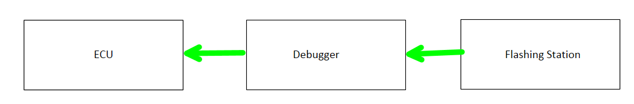

Figure 7 : Connection For Flashing

1. TP Details for Flashing:
   1. TOOL: Data input/output for flash memory programmer/debugger
   2. RESET: External reset input
   3. +5V: Positive power supply: 5V supply from Debugger
   4. GND VDD:Ground potential

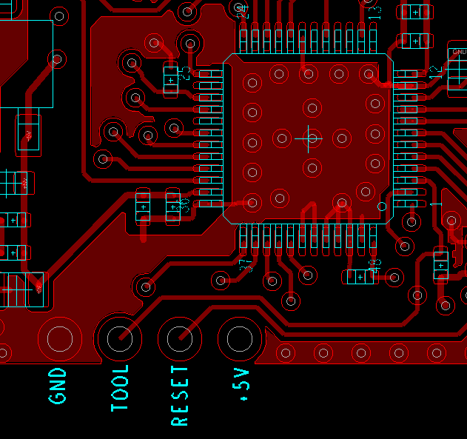

Figure 8 : TP for Flashing

1. Serial number Write and Read will be done using the Golden ECU.
2. Connection Details with the Golden ECU:

# Device description

*The devices to be tested during the development and in series production have to be described in the following sections.*

## Brief description

*A brief description of the devices to be tested must be included as first overview.*

E.g. Functional overview, construction (if applicable reference to drawings), variant table with assigned functions, interfaces parameters (type, baud rate, sampling time, connected HW...)

RPAS system is Reverse Park Assist System, system that is designed to alert the driver about obstacles on the rear side of vehicles while parking in reverse, which assist / help to driver while vehicle's reverse gear is engaged. RPAS system includes ECU, Ultrasonic sensors, and alarm output through acoustic and failure indication through Visual i.e. LED

HELLA "RPAS" system can be used for all passenger vehicles and commercial vehicles in Indian market as per AIS 145 Annexure 6 and 7.

RPAS system should be used as per specified requirements. This system is only monitoring system and assisting to driver with warning information when vehicle's reverse gear is engaged. This system will not control the vehicle's brake or speed etc.

The Complete Package of "RPAS" is considered as a controller /ECU (processing device) , Ultrasonic sensors (4 numbers) and bezels (4 numbers) For Customer "DICV".

The purpose of the complete system "RPAS" is to

- provide power supply to external systems for sensing

- handle the sensor drive and object detection

- handle the input communication for reverse switch and park assist switch

- activate and drive external malfunction indication lamp in case of failures.

- activate and drive external buzzer in case of failures / warnings.

- handle communication, diagnosis and acquire information from external sensors (Ultrasonic sensors). CAN communication will not be part of final product. It is considered as package protection

- handle communication with external systems for diagnosis, communication, reprogram ability [Package protected]

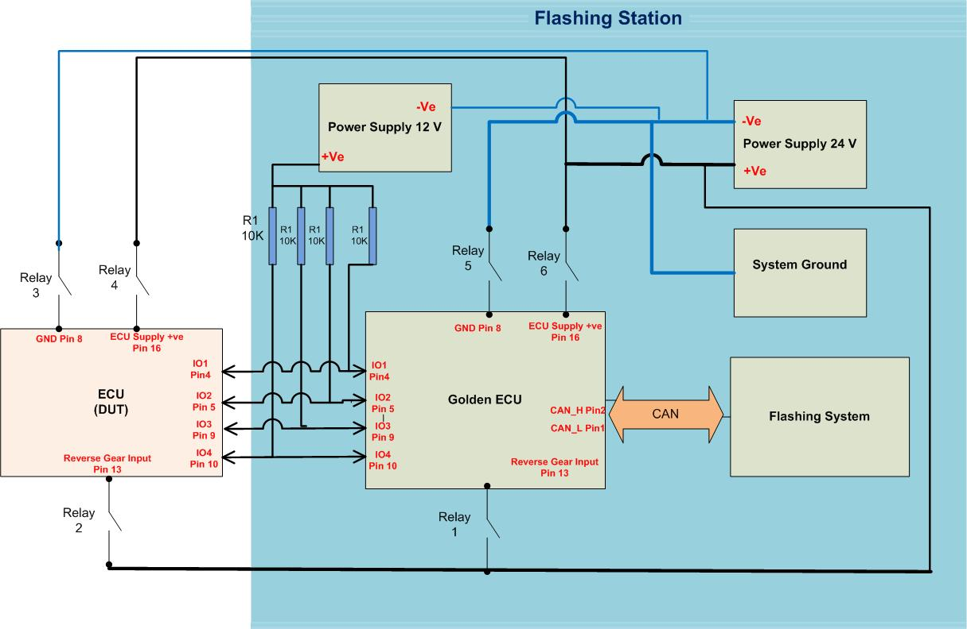

Figure 9 : wiring Diagram Serial number Read/Write

1. Unique serial number (PCB DMC) will be send to the Golden ECU Over CAN message. Golden ECU will write the serial number into the ECU and give acknowledgement via CAN.
2. System will send the request to Golden ECU to read serial number Over CAN. Golden ECU will Read Serial number from ECU and will reflect on CAN message.
3. If connector is not available at flashing station then following TP can be used

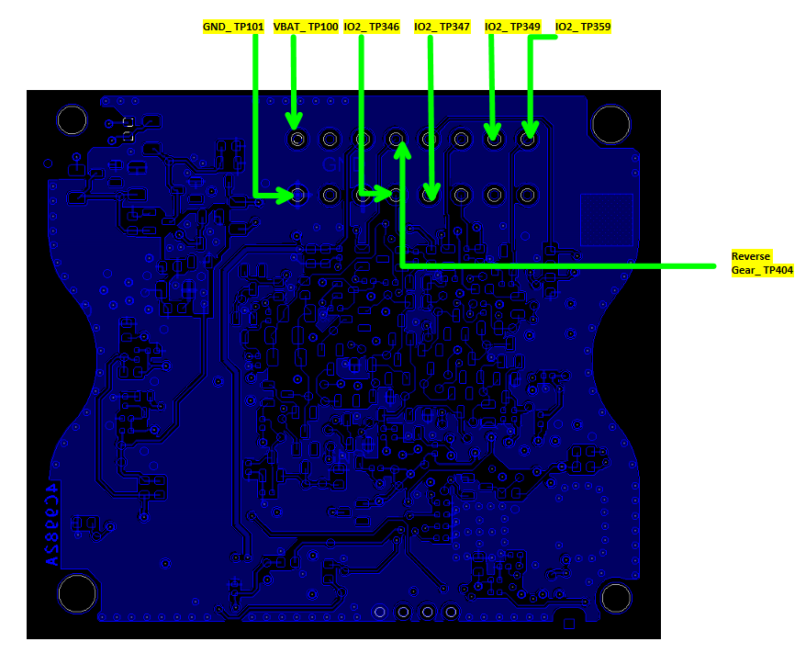

Figure 10 : TP for Serial number Write/Read

1. Serial Number Write/Read Sequence.
   1. Switch ON Power Supply with 24V.
   2. Connect Relay 6, Relay 4, Relay 5, Relay 3 to power on GOLDEN ECU and ECU(DUT).
   3. Connect Relay 1 and Relay 2 to make reaverse Gear Engage
   4. Wait for 100 msec
   5. Send Serial number on CAN message to the Golden ECU.
   6. Check for the No ERROR Frames for the sent CAN messgae
   7. Wait for 200 msec
   8. Send Command to Golden ECU Over CAN to Read the Serial Number from ECU(DUT).
   9. Check for the No ERROR Frames for the sent CAN messgae
   10. Wait for 100 msec
   11. Read the Serial number Received over CAN
   12. Verifiy the Received Serial number with the one that was written in the ECU.
2. Flashing Machine sequence:
   1. Operator will place the PCBA on fixture.
   2. Now operator will close the fixture cover.
   3. Now scanner will read the DMC code from PCBA to check whether it is passed from previous station or not.
   4. If it is passed then flashing (.hex/ .rec file) will start. If not then flashing will not start.
   5. Verify checksum w.r.t. HMF file
   6. Serial Number (DMC Code) Write and Read to verify
   7. Upload Traceability data PASS/FAIL to MES.
   8. Release the Part.
   9. If any of the above step is FAIL, follow rejection part procedure
   10. In case of PASS result, operator will unload the OK part & move it to next station.

# Leakage Tester

**Serial Number Read (DMC Code):**

1. Serial number Read will be done using the Golden ECU.
2. Connection Details with the Golden ECU:



Figure 11 : wiring Diagram Serial number Read/Write

1. System will send the request to Golden ECU to read serial number (PCB DMC) Over CAN. Golden ECU will Read Serial number from ECU and will reflect on CAN message.
2. Serial Number Read Sequence.
   1. Switch ON Power Supply with 24V.
   2. Connect Relay 6, Relay 4, Relay 5, Relay 3 to power on GOLDEN ECU and ECU(DUT).
   3. Connect Relay 1 and Relay 2 to make reaverse Gear Engage
   4. Wait for 100 msec
   5. Send Command to Golden ECU Over CAN to Read the Serial Number from ECU(DUT).
   6. Check for the No ERROR Frames for the sent CAN messgae
   7. Wait for 100 msec
   8. Read the Serial number Received over CAN
   9. Verifiy the Received Serial number.

**Leakage requirements**

Leakage Tester should test the leakage requirement for IP 67 as per ISO Standard

**Sequence:**

1. Operator will read the Serial Number (DMC Code) and check whether it is passed from previous station or not.
2. Operator will perform the Leakage Test
3. Upload Traceability data PASS/FAIL to MES.
4. Release the Part.
5. If any of the above step is FAIL, follow rejection part procedure
6. In case of PASS result, operator will unload the OK part & move it to next station.

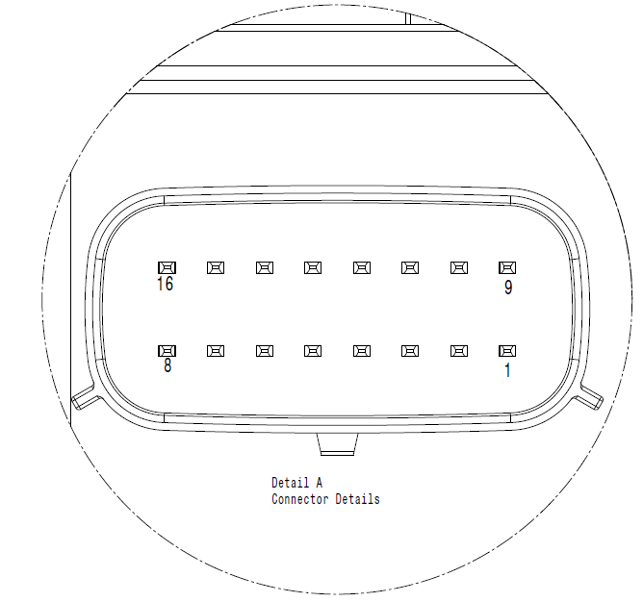

Figure 4 : Mating Connector Picture

|  |  |  |  |  |  |  |  |
| --- | --- | --- | --- | --- | --- | --- | --- |
| **PIN NO.** | **NAME** | **PIN DESRIPTION** | **USED** | **ACTIVE LEVEL** | **SIGNAL TYPE** | **SIGNAL DESTINATION** | **REMARKS** |
| 1 | CANH | CAN COMMUNICATION | N | - | CAN | BUS | PACKAGE PROTECTED |
| 2 | CANL | CAN COMMUNICATION | N | - | CAN | BUS | PACKAGE PROTECTED |
| 3 | FIL_LED | FAULT INDICATION LED SIGNAL | Y | LOW | DIGITAL | OUTPUT | - |
| 4 | SENSOR1_IO | SENSOR 1 COMMUNICATION | Y | - | DIGITAL | INPUT / OUTPUT | - |
| 5 | SENSOR2_IO | SENSOR 2 COMMUNICATION | Y | - | DIGITAL | INPUT / OUTPUT | - |
| 6 | SENSOR_GROUND | ALL SENSOR GROUND | Y | - | GND | GROUND | - |
| 7 | BUZZER_SIGNAL | BUZZER SIGNAL | Y | LOW | DIGITAL | OUTPUT | - |
| 8 | GROUND | POWER SUPPLY GROUND | Y | - | GND | GROUND | - |
| 9 | SENSOR3_IO | SENSOR 3 COMMUNICATION | Y | - | DIGITAL | INPUT / OUTPUT | - |
| 10 | SENSOR4_IO | SENSOR 4 COMMUNICATION | Y | - | DIGITAL | INPUT / OUTPUT | - |
| 11 | PARK_ASSIST_INPUT* | PARK ASSIST INPUT SIGNAL | N | HIGH | DIGITAL | INPUT | PACKAGE PROTECTED |
| 12 | - | - | N | - | - | - | HELLA INTERNAL USE |
| 13 | REVERSE_GEAR_INPUT | REVERSE GEAR INPUT SIGNAL | Y | HIGH | DIGITAL | INPUT | - |
| 14 | SENSOR_POWER_SUPPLY | SENSOR POWER SUPPLY | Y | HIGH | DIGITAL | OUTPUT | - |
| 15 | - | - | N | - | - | - | HELLA INTERNAL USE |
| 16 | POWER_SUPPLY | IGINITION POWER SUPPLY | Y | - | IGNITION | - | - |

Figure 5 : Connector Pinning Details

*\*Note: Pinning details for AL will be different.for AL, addition of learning input pin*